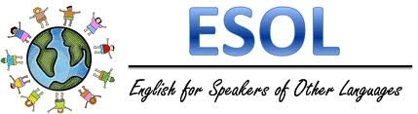

### Montessori Academy

Rochester, NY

November 2016

Ms. Harris’s Classroom Newsletter

We have finished reading Esperanza Rising in class and are now working on a book report based on the main character in the book. Students will bring their reports home to share with you next week.

Next week we will start reading *Island of the Blue Dolphin*. We will continue to improve understanding of vocabulary, but also focus on heavily on comprehension skills and using evidence from the text to support their answer.

# 5th Grade

Students in 3rd-6th Grade are using a new vocabulary program called Wordly Wise in school. It can be accessed online while out of school to give students additional help with their vocabulary. Online, you will find word lists, pronunciations, review, and games with the vocabulary. I highly recommend this added support to be used outside of school. The website is: [www.wordlywise3000.com](http://www.wordlywise3000.com)



# 2nd Grade

Last month, students focused on reading, answering, and using questions words: *who, what, where, when, why,* and *how*. We have also been working on using and recognizing homophones, specifically their, there, they’re, to, too, two, your, and you’re.

This month we will continue to work with homophones, but incorporate past tense verbs. Students will understand what a past tense verb is and when it is appropriate to use them.

We just finished writing a narrative about a time when a friend did something nice for them. Their stories came out very nice. Please ask your student to read you what they wrote.

Students have been working diligently on their vocabulary in Wordly Wise. They are learning the spelling and definition of multisyllabic words (words that have more than one syllable) and using them in their reading and writing.

# 3rd Grade-Feldstein & 4th Grade

Your student has been working diligently to use all four modalities: speaking, listening, reading, and writing while learning about Native Americans, specifically the Iroquois. We will be focusing on sentence structure of simple sentence and compound sentences in our reading and writing. To do this we will be using the facts and details we have learned in our reading.

# 3rd Grade- Kester

# What’s new?